

**Services encased or surrounded by concrete**

Services encased or surrounded by concrete pose additional risks.

The concrete may be concealing faults, adversely loading the services, weakening them, or preventing accurate identification of the service(s). The concrete may provide anchorage to pipelines and associated fittings and there removal or complete exposure of the concrete should be avoided to minimise the risk of failure of the anchor block. In addition, the removal of concrete will almost always require more aggressive techniques than exposing services in normal or soft ground or which have been properly bedded.

The combination of the unknown, with additional force required to remove the concrete (even if only to create space for a component or working room) brings additional risk to those carrying out the work.

The principle that when any service is discovered to be encased or surrounded by concrete **work must stop,** to establish the reason for the concrete being present. Ideally a **diversion** or (if that is not reasonably practicable) **isolation** of the services should be adopted. This “decision map” / “Flow-chart” should be used, which is equally applicable at design (survey) stage as it is in construction or maintenance stages.

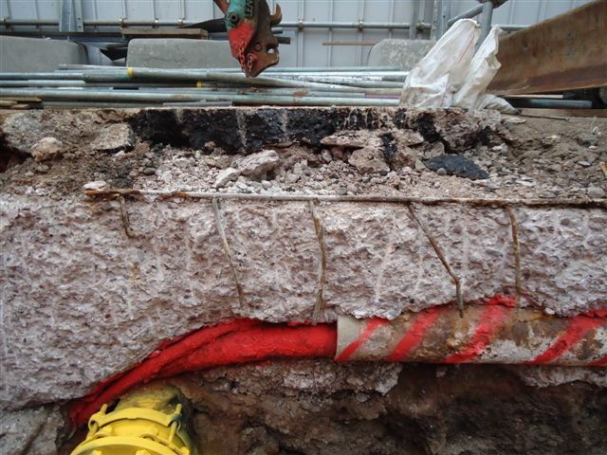

The decision map / flow chart (Item 7 on the micro-site) describes a simple way to manage the discovery of services encased in or surrounded by concrete.

This is primarily aimed at site supervisors, team leaders and site managers, but is also applicable to designers / planners.