Underbridge Paving
Lessons Learnt Workshop
Date: August 2019

**Date**
**Issue**

Document Control
Document Title: | Underbridge Paving – Lessons Learnt
Document Number: | [#REF] Document controller to supply doc number from BC
Author: | Louisa Todd
Owner: | Louisa Todd
Distribution: | Operational Excellence Team, HS&W Team
Document Status: | DRAFT

Introduction

Operational Excellence Team (OpEx) were asked by Phil Leng, Director of Operational Safety, to conduct a lesson learnt workshop on underbridge paving, following a RIDDOR.

Current Situation

Unlike other sections, Section 3 structures have an underbridge area, built up by earthworks. This slope is at a 45-degree angle. A decision, at design stage, was made that this area was to be paved, with concrete paving slabs. This would deter from vegetation growing and animals burrowing under the bridge.

There is a four step process involved in laying the slabs: 1. Prep 2. Slabbing 3. Finishing 4. Landscaping.

The slabs are 600x600mm and weighing 42kg.

The gangs lay these slabs whilst wearing harnesses, which are anchored at the top of the slope.

This process takes 10 days to complete and costs £23,000 per structure.

As you can see from the pictures below, the concrete slabs are laid in line with the structure, and a neat line is cut in the slabs.
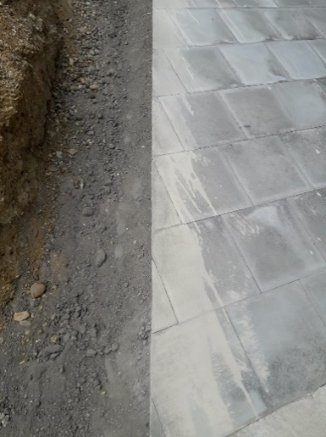
Below picture shows waste material resulted from cutting of the slabs.

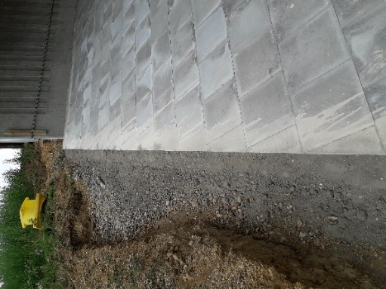

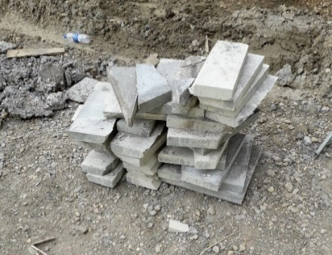

The below pictures are a depiction of how the slabs are installed.

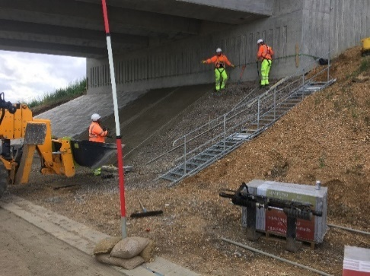
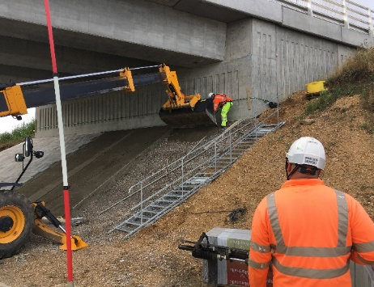

The Workshop

Pros | Cons
Prevents against erosion. | Cost – for Section 3 it costs £23,000 per structure for 10 structures in total.
Protects the land against wildlife i.e. Rabbits. | Risks to people:  HAVS – due to the cutting of the slab.  Silica dust – due to the cutting of the slab.  Noise – due to the cutting of the slab.  Working at height  Manual handling – due to the 45kg weigh per slab.
Aesthetic reasoning. | Access Difficulties for material, people and plant.
It is robust. | People/Plant interface – working in a confined space.
 | Specialist training - due to the nature of the work, training is required to support working at height, plant handling and confined spaces.
 | Temporary Works
 | Testing
 | Use of non standard kit.
 | Time – current operations take 10 days to complete with the use of a 4 man gang.
 | Constraint to surfacing – this operation needs to be completed prior to surfacing.
The way the workshop was conducted was by looking at the pros and cons of the original method.

Solutions

Following the discussion around pros and cons, the group then looked at possible solutions. These have been highlighted below.

Larger Slabs – These slabs could be precast and then installed. This operation would require the use of specialised plant – policy dicates that the use of underslinging is prohibited.

However, a case could be made with the correct risk assessments. There is also a challenge with headroom at the top of the slopes to sling correctly.

LPS – Due to working under structures, GPS cannot be used, however LPS and machine control could be used in the setting out and laying of the sub-base, but will still be labour intensive to lay the slabs.

Fire Retardant GRP (Glass Reinforced Plastic) – This would incur large maintenance costs and may also present a fire hazard (smoke across the carriageway etc).

Grasscrete – Lighter in weight, which would reduce the risk of manual handling accidents. Does not require grass for stability. Comes in plastic and in concrete. Reduces the level of sub-base. Rubber pellets or other materials could be used to infill.

Geo Grid – Similar to Grasscrete. This would need to be fire retardant due to the proximity to the carriage way.

Stone Pitches - Would need to be laid correctly to get the required finished. Use to match the terrain/location of the structure. Likely to be expensive if any maintenance required.

Gabion Baskets – This is an expensive solutions. Requires a lot of time and the correctly skilled people to install and fill.

Smaller Paving Slabs – This will reduce the weight of the paving slab, however this would require more slabs to be laid, and still does not address the cons highlighted above.

Spray Concrete/Shotcrete – Does not have the asthetically pleasing look.

Change of design - With a change of design, this could reduce the working at height risk by introducing mid way landings. Please see below picture:
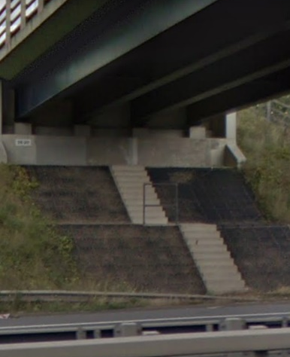

Image taken from Google Maps.

Concrete Canvas “Dutch Lining” – A woven mat laid from a roll with concrete sandwich in between the two layers. Does not give a good finish.

Landscaping – Currently landscaping is not used due to the lack of light and water to the area.

Reduce Paving – If paving were to be reduced, for example, pave the centre third (and not cut the slabs) and landscape the outer thirds. This would heavily reduce the risk to the gangs and save on costs.

New Material – looking at an alternative, a spray asphalt. There are companies that offer this service. Costs are undetermined to date – further research is needed.

Next Steps

There is one structure left on Section 3 (BN16), where one of the proposed solutions could be implemented. A detailed plan needs to be created.

Further research into the “new material” is to be completed by the OpEx Team and a report to follow.

Cost benefits for solutions need to formulated – conducted by OpEx Team.

