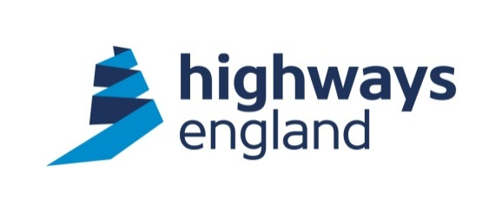­

**Operative struck by moving vehicle on site**

*SafetyAlert*

**October 2016**

**Actions:**

* **Review plant & people interface risk assessments and controls.**
* **As per Raising the Bar 3 the risk assessment process for all mobile plant / vehicles must have a Risk / No Risk Zone identified, with the risk zone acting as an exclusion area for all persons.**
* **Where it is not possible to physically segregate persons from entering the risk zone, then an effective control system (e.g. proximity warning technology, mechanical restrictor) should be selected, implemented and established as a minimum around all moving plant.**
* **Consider whether vehicles are adequately lit and visible.**
* **Consider illuminating extending or protruding elements of vehicles.**
* **For further advice and guidance on plant person interface can be found on the** [**Highways Safety Hub**](http://www.highwayssafetyhub.com/plant--road-vehicleinterface) **website.**

**Description:**

On the 27th September 2016 at 00:15 a traffic management operative was struck by an extended arm protruding from a white lining van on site.

The van was applying a drip line to facilitate revised temporary white lines between lanes 2 and 3 of the new carriageway. The operative was assisting in the removal of temporary white lines prior to a change in the carriageway traffic flow.

The operative moved to the offside of the van, as the vehicle passed the operative at walking speed, a metal bar which extended 1.2metres from the side of the vehicle struck the lower leg of the operative causing him to fall to the ground and causing a fracture to his wrist.

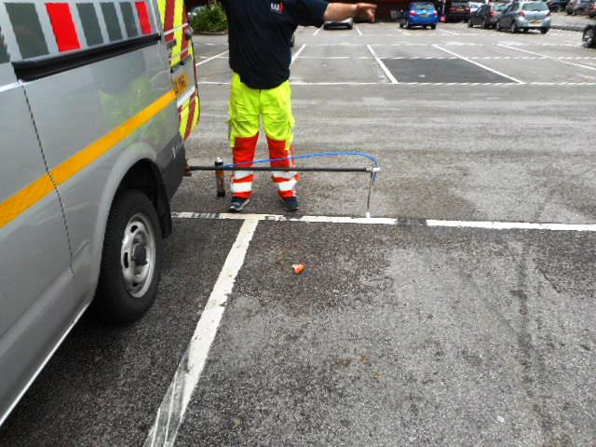

(Drip bar protruding from the white lining van)

**Investigation/ findings:**

* The operative stood too close to a moving vehicle. A 3 meter rule should have been observed.
* Failure to ensure that the route was clear of personnel prior to starting the white lining activity.
* Drip bar was not illuminated and was therefore not visible in night time conditions.

**HE 187**

**Further Information:**

For further information please call

Ross Kennedy on 0300 470 2479 or email ross.kennedy@highwaysengland.co.uk