Highways Fatigue Management Plan

Project /Contract Name:

Project / Contract Number:

Document Prepared By | Name | Date | Signature

Revision Record
Date | Details of Changes Made | By Whom | Signed

Contents
Contents | 2
Reference Material | 3
Introduction | 4
Purpose | 4
Legal Requirement | 4
Summary of Working Time Regulations | 5
Standard Rules | 6
Night Work | 7
Young Workers | 7
Definitions | 7
Responsibilities | 9
Process | 11
On Call Arrangement | 12
Agency and Labour only | 12
Supply Chain | 12
Work Related Accommodation | 12
Risk Assessment | 12
Risk Factors | 13
Planning Safe Working Hours | 13
Authorisation of excessive Hours | 14
Communication & Training | 15
Records | 15
Compliance | 15
Appendices:
1 Proposed Time Sheet | 16
2 Extension of Working Hours Risk Assessment | 17
3 Authorisation to Work Excessive Hours | 19
4 Nine Stage Approach | 20
5 Activity Risk Table | 21
6 Model Work Activity Flow Charts | 23
- Office Workers | 23
- Routine Maintenance | 24
- Incident Response | 25
- Traffic Management | 26
- Winter Working | 27
- Surfacing | 28
- Temporary Vehicle Restraint Systems | 29
- White Lining | 30
- Office Workers Who Visit Site | 31
- Inspections/Lone Working | 32

Reference Material

- INTERIM ADVICE NOTE 189/16 Policy on Managing Fatigue in the Workplace May 2016.
- INTERIM ADVICE NOTE 190/16 Guidance on Processes for Managing Fatigue in the Workplace May 2016.
- Insert reference to your company procedure for Fatigue Management
- Your guide to the Working Time Regulations, URN No: 06/1237A and 06/1237B; DTI 2006(available from DTI’s publications order line Tel: 0870 150 2500).
- Office of Rail Regulation 2006; Guidance on Managing fatigue in safety-critical work (as applicable to business specifics).
- Health & Safety at Work etc. Act 1974 (c.37) The Stationery Office 1974 ISBN 0 105437743.
- Management of health and safety at work: Management of Health and Safety at Work Regulations 1999. Approved Code of Practice and guidance L21 (Second edition) HSE Books 2000 ISBN 0 7176 2488 9.

Introduction
This document is part of the Fatigue Risk Management System and details the requirements to meet the current statutory, corporate and client’s requirements for managing working times and fatigue risk on the project / contract. This Plan has been developed in alignment with IAN 189/16, IAN 190/16 and Balfour Beatty HSEN-PC-0065 – Fatigue Management procedure.

Scope

This Plan applies to all personnel on Balfour Beatty Highways projects/contracts and includes supply chain and agency staff. The Plan details how work will be controlled across the project/contract to ensure the requirements can be met throughout the duration of the project/contract.
Exemptions from this Plan are HGV and PSV drivers who are covered by other legislation governing driver’s hours. The document has intentionally omitted reference to traffic management operations as these are undergoing a separate review involving the Highways Term Maintenance Association (HTMA), Traffic Management Contractors Association (TMCA) and the Health and Safety Laboratories (HSL)

Purpose

Managing fatigue is one of the components of our overall approach to fitness and wellbeing at work. Fatigue is recognised as a potential safety and health risk factor which needs to be managed and controlled as part of our duty of care responsibilities to the workforce. The Plan details individual responsibilities that, when implemented correctly, will reduce the risk of fatigue and its effects on the project/contract.

The requirements of this Plan apply where activities such as the structure of the shift length, the shift roster, the nature of the work, commuting, sleeping arrangements and the lifestyle of the individual poses a risk of fatigue.

Legal Requirements

The Working Time Regulations 1998 (SI 1998/1833) is the United Kingdom statutory instrument which implements the EU Working Time Directive 2003/88/EC.

These Regulations govern the time that people in the UK may work. The Regulations apply to all workers (not just employees) and stipulate minimum rest breaks, daily rest, weekly rest and the maximum average working week.

Summary of Working Time Regulations

http://www.legislation.gov.uk/uksi/1998/1833/contents/made

Summary of an Individual’s rights and protections that the regulations provide are:
- The working time in any reference period (normally 17 weeks) shall not exceed an average of 48 hours for each 7 days. However, a worker can agree (in writing) to “opt out” of this requirement.
- For workers who opt out, the weekly working time in any 14day period should not exceed an average of 72 hours for each 7 days.
- For night workers i.e. those regularly working at least hours between 23.00 and 06.00, the working time in any reference period (normally 17 weeks) shall not exceed an average of 8 hours for each 24 hours.
- Night workers whose work involves special hazards or heavy physical or mental strain shall not work more than 8 hours in any 24 hour period, during which the night worker performs night work, unless a collective agreement or workforce agreement is in place, in accordance with Working Time Regulations 1998 as amended in 2003.
- An ‘adult worker’ (18 years or older) is entitled to a rest period of not less than 11 consecutive hours in each 12 hour period during which they work for their employer (commuting is not counted as work and therefore considered as rest time with respect to Working Time, but should be taken account of during any risk assessment looking at fatigue).
- Where an ‘adult worker’s’ daily working time is more than 6 hours, they are entitled to a rest break.
- The rest break provided is an uninterrupted period of not less than 20 minutes, and the employee to spend it away from their workstation if they have one.
- Employees have the right to an uninterrupted 24 hours without any work during each week or to an uninterrupted 48 hours during each fortnight.
- Employees working nights are entitled regular health assessments, as defined in the Working Time Regulations 1998 as amended in 2003.
- The duration of shifts is to be no more than 12 hours including rest breaks and overtime.
- Employees are to have 5.6 weeks paid leave a year.

The Regulations also provide enhanced rights for young workers aged between 16 and 18 as follows:
- The weekly limit is 40 hours per week and 8 hours per day;
- They are entitled to a rest break of at least 30 minutes if their daily working time is more than 4.5 hours. These will be consecutive where possible.
- A young worker must not be assigned to night work unless they have undergone a free health assessment of their health and capacities before they take up this assignment.
- Entitled to a rest period of 48 hours in each 7 day period, this may be reduced by technical or organization reasons, but not to less than 36 consecutive hours.

Standard Rules

In addition to the legal requirements in the Working Time Regulations, supplementary Standard Rules (recommended limits) have been developed, in order to mitigate risks causing employee fatigue. These Standard Rules have been developed considering best practice from other business areas including the Rail, Nuclear and Oil & Gas industries. They are of a higher standard than the requirements Working Time Regulations.
STANDAR
D
Standard Rules | HSE Fatigue Tool benchmark Scores ⁽¹⁾ | Examples of Control Measures  (not an exhaustive list)
The working time should not exceed 12 hours in any 24 hour period, with the exception of ‘night workers’ |  | Change shift start./ finish times
Minimum 12 hours rest period between shifts, this includes travel time. |  | Reduction in shift lengths
The door to door time should not be planned to exceed a maximum of 14 hours per shift, this includes commuting time. |  | Lodging in overnight accommodation or reduce commuter time.
The weekly working time should not be planned to exceed a maximum of 60 hours in any 7 day period, unless permitted by the risk assessment and outputs from use of the HSE fatigue tool ⁽¹⁾ |  | Increase frequency / length of breaks
The weekly working time in any 14 day period should not exceed an average of 72 hours for each 7 days. |  | Rotation of alternative staff
No more than 13 shifts to be worked in any 14 day period. |  | Rotation of alternative staff  Review shift patterns
R
Notes:
⁽¹⁾ This column will be completed once the exercise being undertaken by Health & Safety Laboratories has been completed.
Night Works:

The rules about how long workers can work at night are based on an average working time, normally calculated over a 17-week period. If the workers and the employer both agree as part of a collective or workforce agreement, the working hours can be averaged over a longer period, e.g. up to 52 weeks.
- Employers must make sure that workers do not work more than an average of 8 hours in a 24-hour period, particularly where night work involves special hazards or heavy physical or mental strain. Workers cannot opt out of this working limit.
- Night worker health assessments are offered as part of Occupational Health Surveillance – Assessment Procedure.
- Documentation must be held by the Manager of the night workers working hours to prove they are not exceeding night working limits. The Company must keep the records for at least 2 years.
- Provide similar facilities and opportunities for shift workers as those available for day time workers.

Young Workers

- Young workers must not exceed more than eight hours a day or 40 hours a week.
- There is no opt-out agreement for young workers.
- Young workers are entitled to two days off each week and are entitled to a 30 minute rest break for every 4.5 hours worked.

Definitions

For the purposes of this Management Plan the following definitions apply:
- Fatigue: The Health and Safety Executive (HSE) define fatigue as ‘a result of prolonged mental or physical exertion’; it can affect people’s performance and impair their mental alertness, which leads to dangerous errors’ ; recognising that fatigue is not simply ‘tiredness’ and that it has a direct effect on attentiveness/alertness at work.
- Fatigue Management Plan: A Company/Project/Contract approved document which details how work will be controlled across the project/contract to ensure the requirements can be met throughout the duration of the project/contract.
- Risk Assessment/Fatigue Risk Assessment: A systematic process of evaluating the potential risks that may be involved in a projected activity or undertaking; including specifically fatigue.
- Extension of Working Hours Risk Assessment: A risk assessment undertaken when the ‘standard rostered working hours’ are exceeded due to an unplanned event occurring.
- Extended Working Hours: Any working hours in excess of planned rostered hours, this includes overtime.
- Authorisation to Work Excessive Hours: A form used to authorise the exceedance of planned hours during the planning of Rosters after all control measures have been exhausted and the Extension of Working Hours Risk Assessment has been approved.
- Night Worker: A person who ‘regularly’ works for at least 3 hours during the Night Time’ period is a night worker. Workers may also be a night workers if there is a collective agreement that states what counts as night work; and it is likely that they’ll work a proportion of their annual working time during the night.
- Overtime Agreement: If the workers and the employer both agree as part of a collective or workforce agreement, the working hours can be averaged over a longer period, e.g. up to 52 weeks. Employers must make sure that workers don’t work more than an average of 8 hours in a 24-hour period. Workers can’t opt out of this working limit.
- Lifestyle: The habits, attitudes, tastes, moral standards, economic level, etc That together constitute the mode of living of an individual or group.
- Special Hazards: A hazard that is out of their normal work activity. A hazard which is unknown or by which those who are presented by it are not trained in the controls required to mitigate the risk of the hazard; (examples of this are: of a Highways maintenance activity would be; the responding to an incident and finding a tanker containing hazardous explosive or corrosive substance that has overturned. On Major Highways projects / contracts the finding of unexploded ordinance).
- Night Time: In relation to a worker, means a period:
  - the duration of which is not less than 7 hours
  - that includes the period between midnight and 5 a.m.
This should be determined by a relevant agreement or where no such agreement exists the period between 11pm and 6am.
- Night Work: Means work during night time.
- Door to Door Time: Is that period of time identified as the combined total of commuting time, travel time and working time. (see diagram below).
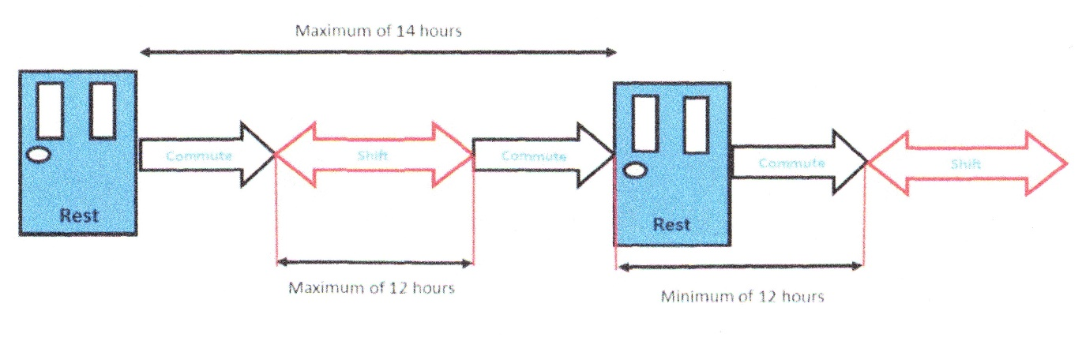
- Suitable accommodation: Is a place that provides a comfortable bed where an individual can have a minimum of 8 hours uninterrupted sleep and a place to eat a meal.
- On Call: On call means waiting to respond to an emergency call out or answering a query from people working in the field.
- Regularly: Is not defined precisely but as defined by the unions must apply to any person who completes 3 or more night shift per week.
- Rostered Hours: The hours for which an employee is rostered to work.
- Shift Work: The hours worked between the start and finish of a shift, excluding any overtime or shift change-over period worked.
- Commuting Time: The time spent travelling from a place of rest to the place of work, likewise from the place of work to a place of rest. This includes passengers and the use of public transport.
- Travel Time: A period of time during which an employee travels whilst at the disposal of the employer, including carrying out activities or duties on behalf of the employer. This type of travel does not include commuting time.
- Work Cycles/Rosters: The working period scheduled between any significant break away from work. Examples include: Two weeks on, one week off; Two days, two nights on followed by four days off; Four weeks on, one week off, etc.
- Work Schedules: The hours to be worked for each day, shift, week, month or year, as scheduled by the project / contract.
- Young Worker: A young worker is someone under 18 but over school leaving age.
- Line Manager: This is the person who puts the person to work and would be generally the section engineer, sub agent, shift manager or supervisor.

Responsibilities

Contract Lead: Has overall responsibility for the implementation of this plan, ensuring that their direct reports comply with this plan through the provision of suitable controls and preventative measures to eliminate, minimise or mitigate the risk to health and safety of individuals caused through fatigue.

Managers: Shall ensure, where reasonably practicable that all work schedules and rosters meet the requirements of the Fatigue Management Plan.

Where overtime is requested or required for operational reasons the manager must:
- Control overtime and shift swapping by monitoring and recording hours worked and rest periods. Employees should be discouraged from taking second jobs.
- Any overtime to rostered hours must be authorised by the manager and shall not exceed four hours per individual. All anomalies must be recorded on weekly timesheets.
- The manager, in responding to overtime requests, must undertake a risk assessment and this shall be included in the working method statement. The extension of working hours risk assessment is at Appendix 2.
- Any exceedance of the recommended maximum limits detailed can only be authorised by senior management / project / contract director and HS&E manager or advisor. The authorisation to work excessive hours form is at Appendix 3.
- If the exceedance arises out of hours or at short notice then the relevant senior manager may only authorise exceedance following completion of a written risk assessment, where mitigating measures to address fatigue risks associated with exceedance in hours is covered.
- Where it is determined that an exceedance is authorised, the risk assessment for exceeding safe working hours must be completed and a record retained.
- Monitor the arrangements for managing fatigue to assess how effectively the risks are being controlled.

Line Managers / Supervisor: Shall ensure that staff and operatives under their management, supervision or control do not carry out work in circumstances where they are likely to be fatigued that their health and safety or that of the person could be affected. The following must be completed before exceeding planned working arrangements.
- All night workers shall receive a health assessment before starting night shift, and then annually or as specified by the Balfour Beatty business management system.
- Notify the Occupational Health Advisor of directly employed night workers (company applicable) who will coordinate the health assessments.
- Ensure that all timesheets are completed at the end of each shift (see Appendix 1).
- Review the arrangements of managing the risks identified with fatigue, when there is reason to doubt the effectiveness of the arrangements.
- Ensure all workers are supplied with clear and relevant information on the risks associated with fatigue and how they will be controlled.
- Produce, review and implement risk assessments, safe systems of work and associated extended hours assessments and authorisations; keep records of documents as required.
- Ensure the people working do not exceed their working hours.
- Ensure authorisation is sought for any works that exceeds the requirements of the Fatigue Management Plan.
- Ensure that every extension of hours risk assessment is reviewed in order to determine any lessons that can be learned to avoid future re-occurrence.
- Must ensure so far as reasonably practicable that any worker who reports for duty where they are clearly unfit owing to fatigue or who through the course of their work shift become clearly unfit owing to fatigue, do not carry out or continue to carry out work.
- Ensure breaks are scheduled appropriately for the type of work and the environmental conditions.
- Ensure employees are allowed some discretion over when they take a break, but are discourage from saving up break up time in order to leave earlier.
- Ensure workplace lighting and temperature is adequate and adjustable by employees to enable them to carry out their tasks in reasonable comfort.
- Ensure the workplace and its surroundings are well lit, safe and secure, enabling employees to work safely and free from threat of violence.

All Personnel: Are empowered to identify individuals who they feel are unfit for work due to whatever circumstances. Each individual turning in for work must:
- Ensure that they are fit for work.
- Ensure the information they provide in regards to commute time and travel time is accurate.
- Ensure so as far as reasonably practicable that any worker who reports for duty where they are clearly unfit owing to fatigue or, who through the course of their work shift, become clearly unfit owing to fatigue, do not carry out or continue to carry out work.
- Inform their supervisor if they feel they are feeling the effects of fatigue.
- Inform their line manager of the hours they have worked over the last 7 days.
- Ensure employees are encouraged to inform their doctor about their working arrangements.

Health & Safety Manager: The Manager is responsible for monitoring the implementation and compliance of the Plan through:
- Establishing a programme fatigue management strategy monitoring.
- Regular review, with the management team, of the plan to ensure control strategies are applied and remain valid.
- Ensuring any changes to this Plan are documented in the relevant section of the business management system.

To assist with mitigation of fatigue the H&S Manager will ensure healthy living strategies such as exercise and improving diet are provided.

On Call Arrangements: The following applies to those personnel on call and are disturbed by work related issues during their rest period:
- If disturbed for more than 3 hours the rest time is added before the start of the next shift.
- If on call for 7 days, then 5 days not on call is provided.

Agency and Labour Only: Agency and labour only personnel are the responsibility of the company employing them. For the purpose of this Fatigue Management Plan they will be treated as direct employees. This should be established during the pre-contract stage meetings and monitored throughout the project/contract.

Supply Chain: (Must comply with the requirements of IAN 189/16 and 190/16)
- Provide information that demonstrates their compliance with IAN 189/16 and 190/16.
- Provide risk assessments where an exceedance has been identified.

Work Related Accommodation: If, during an employee’s planned working time they are likely to exceed 14 hours door to door suitable accommodation is to be provided by the project/contract or the respective supply chain. Any accommodation provided should be suitable for 8 hours sleep and a meal. The site supervisor is responsible for verifying that such accommodation is available. The measure must be considered and clearly planned before work starts.

Risk Assessment

The line manager will identify the shift patterns required to manage the fatigue and record this information in the relevant risk assessment. To assist in the risk assessment process it is recommended that the nine stage approach is adopted at Appendix 4, we have also included an activity risk table; which gives guidance on the level of risk associated with each activity, see Appendix 5.

Each workplace must conduct a risk assessment which addresses fatigue and identifies the controls to be implemented, which minimises the risks relating to fatigue. Risk assessments are to be completed by line managers (including supply chain) for all works intended being carried out on before any work is undertaken.

Where required, a specific risk assessment will be needed for “Excessive” commute times.

The risk assessment should firstly consider who might be harmed by shift work. While all workers are potentially at risk from shift work, consideration should be given to those groups who are more vulnerable. These include:
- Take into consideration the age of the workforce.
- New and expectant mothers.
- Workers with pre-existing health conditions.
- Workers taking medication.

In addition to the above the following points should also be considered when developing the risk assessment:
- The control of working hours.
- The physical and mental demands of the task being completed.
- The time of day or night the work will take place.
- Monitoring the door to door time of the workforce.
- Impact on the road user.

Risk Factors

In terms of assessing the risks, risk factors to be considered should include the following:
- The structure of the work schedules and rosters.
- Irregular work schedules.
- Potential for call-out of shift-work employees for incident response which may result in sleep deprivation and fatigue.
- Shift length in relation to the physical and mental demands of the work and commuting arrangements.
- Proximity of residence or accommodation to worksite.
- Method of travel to and from work available to employees and the risk of commuting accidents. e.g. consider public transport or car sharing.
- Driving at work.
- Workload and type of work undertaken;
  - Environmental factors – e. g Heat, humidity, noise levels, vibration etc.; and
  - Ability to access a balanced diet and frequency of breaks.

Planning Safe Working Hours.

The degree to which fatigue impacts on safety and health depends, to a large extent, on the structure and duration of the shift, the shift roster, the nature of the work, ‘team make-up’, commuting time and method, sleeping arrangements in the home or at site accommodation and the lifestyle of the individual.

The line manager shall continually monitor the progress of works against the planned shift pattern. Examples of typical shift pattern activities are at Appendix 6.

If the line manager identifies the possibility of the shift pattern being overrun he will put in place a contingency plan before making an assessment as to if extending working hours is necessary in order to avoid risk:
- Risk to health and safety of staff or members of the public.
- Significant disruption to services and it is not reasonably practicable to take alternative steps by providing relief staff in such circumstances as:
  - Extreme weather.
  - Equipment failure.
  - Accident or incident of a serious nature.
  - Shortage or unavailability of staff.
  - Completion of a concrete pour.
  - Completion of a demolition.

This risk assessment should consider the following possible alternatives:
- Suspend work.
- Finding relief staff.
- Reducing staff on site.
- Consider extending the length of the shift.

Authorisation of Excessive Hours.

The line manager will undertake a review with the workforce affected; once everyone has agreed and approvals granted the Authorisation to Work Excessive Hour’s form will be completed for each individual. Once discussed and both parties are satisfied there is no additional risk to the employee, others or to the public then the line manager will complete the exceeding hour’s safe working hours risk assessment. Once achieved the line manager or duty manager will be contacted to inform him that the required documents have been completed. It is the line managers responsibility to monitor the employee and if the situation changes stop work

Although the extension has been approved the line manager will take reasonable steps to:
- Relieve the workers as soon as possible.
- Ensure arrangements are made to get the workers back to their place of rest without an increase to risk at the end of the shift.
- Ensure that employees are provided a minimum of 12 hours rest before the next shift.

Communication and Training

Managers must implement the following:
- Provide training and information to employees on the risks associated with shift work and recognising the signs of fatigue.
- Ensure all supply chain staff are advised of the maximum hours and that they apply equally to all supply chain staff.
- Agree on, and ensure timing and procedures for transmitting information to the next shift team is followed at all times.

Records

Records will be kept in accordance with the following requirements: IAN 189/16, IAN 190/16, and Working Time Directive.
- Authorisation forms.
- Timesheets.
- Health Assessments.

Compliance

Each project / contract is to monitor implementation and compliance of the Fatigue Management Plan.

A review of this Plan is to be undertaken as a minimum of every 12 months or when there has been a significant incident or a change in legislation or client requirements.

Time Sheet

Date:
Project name & Number:
Description:
Please make sure you give the Postcode or Place/Name of your place of rest at the Start of Shift and End of Shift
Print Name | Company | Passport No | Supervisor Manager | Role/Duty | Signature In | Hours Since Last Shift | Place of Rest |  | Time off Site | Anticipated length of Shift | Place of Rest |  | Print Name | Total Time Door to Door
 |  |  |  |  |  |  | Full Postcode | Time Left Place of Rest |  |  | Expected Arrival Time | Full Postcode
 |  |  |  |  | .
DECLARATION
By Signing This Form, You Are Declaring That You Are:
Fit For Work, Not Fatigued and Have Not Worked in The Last 12 Hour Period
(Either on This Project or Anywhere Else)

Extension of Hours Risk Assessment
Contract Name & Number:
Please Note The Following:

- This form is to be used to authorise the exceedance of planned hours resulting from an unplanned event. It should be noted that once an employee has signed this form it can still be revised at any time they believe that they are unable to continue work.
- This assessment must only be made if there is an exceptional circumstance’s which:
- Is likely to increase the risks to health and safety of colleagues or the public.
- Is likely to cause significant disruption to the public and is not reasonably practicable to take alternative steps e.g. by providing relief staff.

The circumstances that have led to this situation are (Tick As Required):
Extreme weather conditions
Equipment failure
Accident or serious Incident
Shortage of staff which was not foreseeable e.g. sudden illness and which would cause significant operational
disruption
Other (provide details)
Yes | No
 |  | Has member of staff worked more than 72 hours in previous 7 days?
 |  | Has member of staff worked more than 12 hours in previous shift?
 |  | Has member of staff had less than 12 hours rest between last turn of duty and this shift?
 |  | Has member of staff worked 13 consecutive shifts prior to this turn of duty?
 |  | Does the employee have to drive home? If so, how far?
 |  | Can anyone else drive the employee home?
 |  | Can the employee be booked into a hotel / B&B after the shift rather than drive home?
 |  | Can the employee be put onto non safety critical duties if exceedance cannot be avoided?
 |  | Is the employee rostered back on duty less than 9 hours after this shift will end? If so, need to ensure a minimum 9 hours rest.
What alternatives have been considered and why have they not been implemented?

Details Of Exceedance

Estimated Exceedance Time: |  |  | Additional Hours Or Additional Shifts:
Risk Assessment Number: |  |  | Location:
 |  |  | Date:
 |  |  | Shift:
Method Statement No: |  |  | Operation:
 |  |  | Start Time:
Details Of The Person Who Is Required To Work Extended Hours
Print Name: |  |  | Position:
Company: |  |  | Type of Work:
Induction Number:

Employees Considerations |  |  | Yes | No
Has the employee had their recommended 12 hour (11 hour legal) rest break prior to the start of this shift?
Does the employee show signs of fatigue?
As the person who is required to work extended hours, I confirm that I am not fatigued and am willing to extend my working hours *
Name: | Signature: | Date:
* This can be reviewed at any period of time during or after the extended period if the person feels that they have become fatigued

Authorisation to Work Excessive Hours
Contract Name & Number:
Please Note The Following:
- ONLY ONE EXCEEDANCE FOR A SINGLE INDIVIDUAL MAY BE AUTHORISED ON THIS FORM
- This form is to be used to authorise the exceedance of planned hours during the planning of Rosters after all control measures have been exhausted
- Please ensure that all the control measures considered are recorded before completing and authorising.
Exceeding Safe Working Hours Risk Assessment Number: | Location:
 | Date:
 | Shift:
Method Statement No: | Operation:
 | Start Time:
Name of Person Exceeding Working Hours | Induction No | Code No | Reason for Exceedance
Code Numbers and Description | 01.  Member of staff turn will exceed 12 hours |  |  | 02.  Member of staff will exceed 72 hours in 7 days | 03.  Member of staff will have a rest period of less than 12 hours between shifts |  | 04.  Member of staff will exceed 13 turns in 14 days | 05.  Member of staff will exceed ‘Door to Door’ time of 14 hours
Circumstance (s) Justifying Threshold Breach (tick as required) |  |  |  | No Alternative Resource  Safety Critical Task |  |  | Emergency Works  Other (Provide Details)
Mitigation Measure (s) Identified To Reduce The Additional Risk As Far As Reasonably Practicable:  (Tick As Appropriate) |  | Staying In Local Accommodation  Reduction In Shift(s) Length  Increased Frequency Of Breaks  Reduced Commuting Time |  |  |  |  | Use Of Public Transport  Occupational Health Assessment  Other (Provide Details)
Assessed By Line Manager: |  |  | Print Name: |  |  | Signature:
Assessed By Senior Line Manager: |  |  | Print Name: |  |  | Signature:
Assessed And Agreed By Employee: | Print Name: | Signature: | Time and Date:

Appendix 4 – The Nine Stage Approach

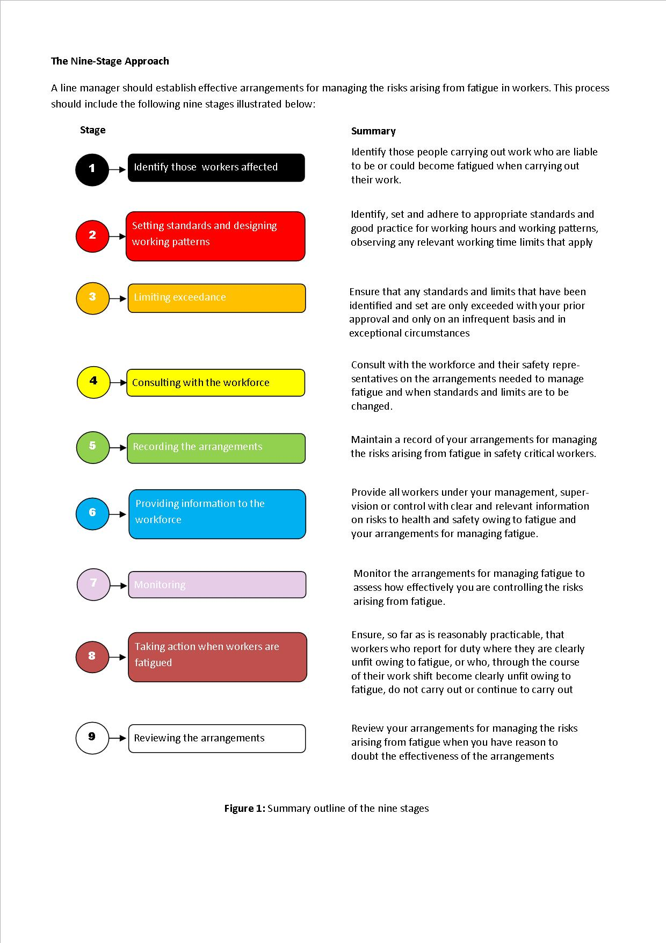

Appendix 5 – Activity Risk Table

Activity | Site Environment | The activity is considered to be of a Special Hazard (SH) / Heavy Physical (HP) / Mental Strain | High Risk Activity | Medium Risk Activity | Low Risk Activity
Drain Laying | Behind TVRS / Shut down |  | X
 | Behind cones |  | X
Lifting / Cranage | Behind TVRS / Shut down |  | X
 | Behind cones |  | X
Surfacing | Behind TVRS / Shut down |  | X
 | Behind cones |  | X
Electrical Work / Comms | Behind TVRS / Shut down |  |  | X
 | Behind cones |  |  | X
Excavations (Machine) | Behind TVRS / Shut down |  | X
 | Behind cones |  | X
Manual Excavation (Trial Holes) | Behind TVRS / Shut down | HP
 | Behind cones | HP
Formwork / FRC / Rebar / Gabion basket | Behind TVRS / Shut down | HP
 | Behind cones | HP
Tm Installation / Removal | Behind cones | HP
TM Maintenance | Behind TVRS / Shut down |  |  | X
 | Behind cones |  | X
Tree Felling / Forestry / Strimming | Behind TVRS / Shut down |  | X
 | Behind cones | HP
Litter Picking | Behind TVRS / Shut down |  | X
 | Behind cones | MS
Commissioning | Behind TVRS / Shut down |  |  | X
 | Without cones | MS
 | Behind cones |  | X
Surveying | Without cones | MS
 | Behind TVRS / Shut down |  |  | X
 | Behind cones |  | X
Scaffold | Behind TVRS / Shut down | HP
 | Behind cones | HP
Security / Gateman | N/A |  |  |  | X
CCTV Operations | N/A |  |  |  | X
Office Based Staff | N/A |  |  |  | X
White Lining / Stud application | Behind TVRS / Shut down |  |  | X
 | Behind cones |  | X
TVRS Installers | Behind TVRS / Shut down |  |  | X
 | Behind cones |  | X
Demolition | Behind TVRS / Shut down | MS
 | Behind cones | MS
Permanent VRS installation | Behind TVRS / Shut down |  |  | X
 | Behind cones |  | X
Site Based Engineering / Staff | Behind TVRS / Shut down |  |  | X
 | Behind cones |  | X
IPV Driver | Live lane |  | X
 | Hard Shoulder |  |  | X
Routine Maintenance Worker | Behind TVRS / Perm VRS |  |  | X
 | Behind cones |  | X
RTMC | Behind TVRS / Shut down |  |  | X
 | Behind cones |  | X

Appendix 6 – Examples of typical shift patterns

