CEMEX – Slips, Trips and Falls
11 short videos

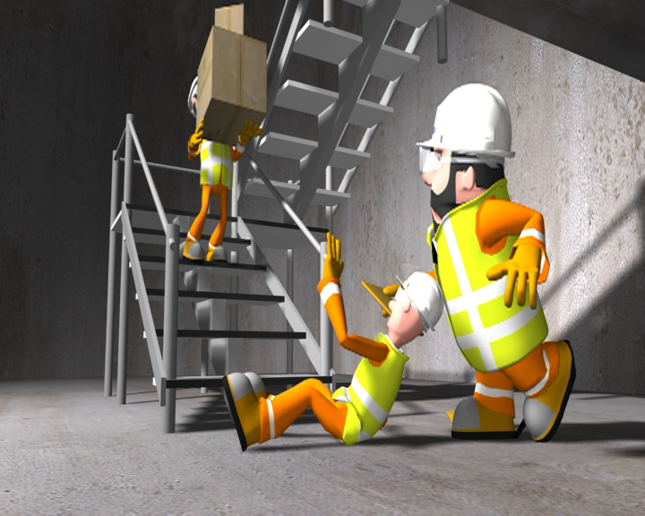

Please follow the links below to an integrated suite of 11 visual aids that help raise awareness of slips, trips and falls in the work place. These are one of the most common causes of accidents and injuries.
The videos can be viewed as a whole or individual scenes selected to highlight particular points. They are ideal for use in toolbox talks, an induction process or as part of a safety training or awareness event.
The resources consist of humorous animations and videos which convey powerful safety messages very clearly. They demonstrate some of the common causes of slips, trips and falls and show how good housekeeping, individuals taking prompt action to remove potential hazards and following basic safety principles can ensure that these types of accidents do not occur.
These visual aids can be used with an audience of any nationality as everything is based on visual rather than spoken or text based messages.
The link below is to the Safequarry YouTube channel where the videos can be viewed. Below this is a list that provides a brief description of the topic covered in each scene and a direct link to it.

LINK TO THE SAFEQUARRY YOUTUBE CHANNEL. PLEASE SCROLL DOWN AND CLICK ON THE RELEVANT SLIPS, TRIPS AND FALLS SCENES
Intro Introduction
Scene 1 Pedestrian routes
Scene 2 Potholes
Scene 3 Muddy boots
Scene 4 Maintain paths and remove trip hazards
Scene 5 Stairs
Scene 6 Snow or icy conditions
Scene 7 Dealing with spillages
Scene 8 Exiting vehicles
Scene 9 Keeping gantries clear
Scene 10 Good housekeeping in workshops

