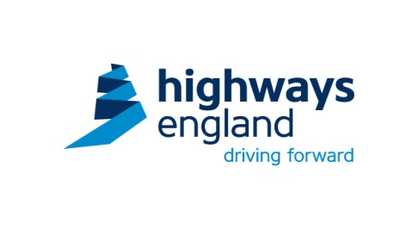

**Blood Pressure Awareness Month – Aug 2015**

**What is normal blood pressure?**

Ideally, we should all have a BP below 120 over 80 (120/80). This is the ideal BP for people wishing to have good health. At this level, we have a much lower risk of heart disease or stroke.

**How to test your Blood Pressure (BP)**

Please take advantage of the simple BP testing kits available on our sites and offices. It is really easy to use but please observe the following simple rules:

* Do not measure if you have eaten, drunk caffeine or alcohol, smoked or exercised during the previous 30 mins
* Check your BP at the same time of day
* Always use the same arm
* Do not move or talk when measuring your BP
* Take two or three readings, each about two minutes apart, and then work out the average.

The test itself:

* You should be in a relaxed state – do the test in a quiet location
* You should be sitting down with a straight back, your feet flat on floor and arm bent at elbow resting on table
* Put the cuff round your arm, with the air tube running down inside of forearm
* Press on/off switch. Your readings will then appear after a few seconds.

That’s it!

**What do blood pressure readings mean?**

**The Blood pressure chart for adults** below shows ranges of high, low and healthy blood pressure readings**:**

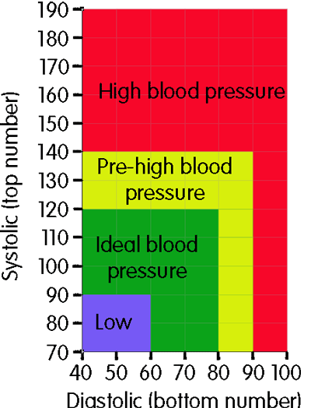

**What is High Blood pressure?**

Your may have *high* BP if your:

* top number is 140 or more *(regardless of bottom number)*
* bottom number is 90 or more *(regardless of top number)*

over a number of weeks.

If you have high readings

* Consult your GP
* Consider lifestyle changes

**What is low Blood Pressure?**

You may have *low* BP if your:

* top number is 90 or less *(regardless of bottom number)*
* bottom number is 60 or less *(regardless of top number)*

Low BP is generally no cause for concern & no treatment is required. However it can lead to dizziness or feeling faint. If your BP is suddenly lower than normal, consult your GP.