Principal Designer Working Group (PDWG)
Working on behalf of HIGHWAY ENGLAND
Meeting No.9
Minutes of the Principal Designer Working Group Meeting / Workshop No.9 – 18th May 2018

Location: Arcadis Offices, Cornerblock, 2 Cornwall Street, Birmingham B3 2DX
Time: 10.00am to 3:30pm.
Attendees:
Name | Initials | Position | Organisation
Richard Wilson | RW | H&S Director (Major Projects) | Highways England
Etienne De Toney | EDT | H & S Lead CIP (HE) | Highways England
Doug Potter (Chair) | DP | Principal Designer Manager | Arcadis
Mark Lamport | ML | Principal Designer Manager | Arcadis
Pav Singh | PSi | Principal Designer Manager | Arcadis
Tim Goddard | TG | Principal Designer Manager | Arcadis
Ed French | EF | Principal Designer Manager | Arcadis
Paul Brown | PB | Technical Manager | WSP Group
Jonathan Giles | JG | Divisional Team Manager, Principal Designer | WSP Group
Jon Horrill | JH | Principal Designer / H & S | WSP Group
Simon Bourne | SB | Technical Director | Mott MacDonald
Simon Wilkinson | SWi | Technical Director | Aecom
Rob Wood | RW | Associate Director | Amey
Andrew Finch | AF | Director of Operations | Jacobs
Roger Swainston | RS | PD / CDM Advisor | Jacobs
Chris Wearne | CW | Lean Practitioner | Jacobs
Richard Jones | RJ | Technical Solutions Manager | Balfour Beatty
Nick Boyle | NB | Technical Solutions Director | Balfour Beatty
Malcolm Shaw | MS | Principal Designer SMP M1 23-25a | Arup
Toria Thomas | TT | Principal Designer | Arup
Tim Bowles | TB | Principal Designer | Atkins
Emma Codrington | EC | AIG – BIM Lead | Highways England
Kevin McPherson | KM | AIG | TRL / Highways England
Libby Allport | LA | AIG | Highways England
Steve Hamer | SH | Technical Manager | Skanska
Liz Braithwaite | LB | H&S Manager | Skanska
Owen Jenkins | OJ | Director | Ciria
Apologies:
Name | Initials | Position | Organisation
Julia Johnson | JJ | Director of Operations | Jacobs
Steve Davey | SD | Head of Technical Standards | Highways England
Dave Morrow | DM | Principal Designer | WSP Group
Ian Lockwood | IL | RIP North Lead | Highways England
Dave Garton | DG | Portfolio Lead H&S, HE & RA | Jacobs
Peter Foster | PF | Principal Designer Area 9 & Section 278 Project Manager | Kier
Shirley Worrell | SWo | PCF Assurance Manager | Highways England
Steve Yates | SY | Principal Designer | Jacobs
Rob Butler | RB | PD & Q.A Manager | Highways England
David Townsend | DT | Head of Policy and Compliance, H&S Team | Highways England
David Owens | DO | Highways England BIM Team | Highways England
Nigel Yeatman | NY | Area 12 Asset Manager | AOne+
Jeremy Bird | JB | Head of H&S Delivery | Highways England
Nicola Knowles | NK | Principal Designer Manager | Arcadis
Leventia Stoiou | LS | Structural Advisor | Highways England
John Winson | JW | Principal Designer | Atkins

Actions:
Ref | Topic | Action  Owner | Deadline
 | General
 | The general purpose of the meeting was to discuss and provide actions for the relevant issues within the structure of the agenda. | Note
1.0 | Welcome and Safety Moment
1.1 | Attendees introduced and apologies for absentees noted
1.2 | Safety Moment  NB provided the Safety Moment – Safe by Design and Engineering – Florida Bridge Collapse including You Tube Footage Link – Attached to minutes.  A great example of what can go wrong when there is a lack of communication within the Project Team | Note
2.0  2.1  2.2  2.3  2.4  2.5  2.6 | C 769 Implementing Lean in construction - Health and Safety synergies of Lean - The new CIRIA Guide (Copy of presentation attached)  Owen Jenkins – CIRIA  OJ introduced the new ciria guide C769 which was developed and published in 2017 and sponsored by the Lean Team within Highways England. It builds on the work of Raising the Bar 21 Lean-Health and Safety and a number of Lean guides already published by ciria within the ‘Implementing Lean in Construction’ suite of documents produced in recent years to improve construction operations.  The objectives of the guide are to: -  - Provide assistance to organisations who are not familiar with the use of Lean;  - Highlight the benefits of Lean to deliver improvements in H&S;  - Detail the various Lean tools and techniques available;  - Highlight the benefits of emerging digital technology to develop process improvements; and  - Provide Case Study which example the use of Lean in delivering H&S benefits on recent HE schemes.  PDWG had worked with the consultation panel assembled to review the documentation and had provided a number of Case Studies now included within the guide.  Ciria Lean guides are available to download at www.ciria.org/lean -  OJ confirmed that ciria would be organising a workshop on 10th July – Introduction to Lean and H & S at the ciria Office in London. DP would forward the invite once the arrangements had been confirmed.  Lean Workshop  CW introduced the Lean Workshop which had been arranged for the afternoon session. He reminded all the questions sent out with the agenda and asked everyone to jot down any issues throughout the morning on the note pads dotted around the room.  The intention was to review the comments during the afternoon session to identify any Lean H&S process issues /improvements that had been identified and which could be worked on by the group going forward. | Actioned  All | 10.7.18
3.0 | Highways England new CDM Audit Process
3.1  3.2 | (John Winson had sent his apologies)  Mark Lamport – Arcadis  (Copy of presentation attached)  ML provided a brief update based on a presentation previously delivered by JW in October 2017.  ML noted that Atkins had developed a CDM Design Office Audit process on behalf of HE and that the intention was to role the audit process out across the current RIP schemes. The proposed process comprised 10 questions to test safe by design measures which covered the following fundamental areas;  - Do I know how the new asset will be assembled;  - Have we considered how it will behave during construction;  - What impact will the construction sequence have on the design;  - Has a construction method been considered in my design;  - What plant is required;  - What access is available/required; and  - What are the sensitivities etc.  o ML reviewed the design audit scoresheet (See Slide 3).
4.1 | Highways England Safety Management System - Status of IAN 105
4.1.1  4.1.2  4.1.3  4.1.4  4.1.5  4.1.6  4.1.7  4.1.8 | (Etienne De Toney) – Highways England (Presentation attached)  Background  ET provided an update on the status of the proposed updated HE Safety Management System (SMS). He indicated HE have a working group currently looking at developing documentation to supersede IAN 105 to ensure that CDM 2015 is fully compliant within HE systems.  The following key areas are being addressed: -  - HE CDM procedures on the HSMS;  - IAN 105 & Associated IAN's e.g. 182 (noting 182/14a had just been released);  - The PCF Framework & the associated CDM related products;  - Guidance Templates for the management of elements / duties under CDM - Predominately Client side, but in certain instances the supply chain; and  - Framework / Commonality of approach across Major Projects (MP) with the diverging contracting models and aspirations of MP and Operations.  PS asked if HE could issue the revised GD05, IAN105, etc or at least interim documents with details on the release dates of the completed documents.  EDT felt this may be possible, but it was noted that the understanding is that IAN's are not being revised / released at this present time – ET to clarify.  EDT indicated that it was his understanding that GD05 will be updated in early 2019. PS advised that at the previous PDWG – the DMRB team had indicated that safety documentation would be removed from DMRB. It was therefore still unclear how IAN’s would be incorporated within the DMRB updates.  Similarly, it was understood that the current revision of IAN 69 will come within DMRB – there is confusion on this point at present.  EDT said that a review exercise was occurring within HE relating to current IAN's to determine the best forward. He would provide feedback.  EDT indicated that HE’s aspirations were to: -  - Provide consistency across HE’s project delivery / improve contract safety management & engineering / define safety functions and have agreed requirements, so that all understand what is expected of them;  - Provide better clarity to the supply chain of CDM expectations when working with HE; and  - Ensure compatibility within HE and supply chain when working across a number of projects.  HE SMS Procedural Proposals  Implications for PD  - That all HE projects / schemes will have a Pre-Construction H & S Plan;  - Greater focus on the team delivery of the PD role (with resourcing of the team from a - Technical, Planning, H & S and Assurance perspective) rather than through individuals;  - Removal of the Additional Duties, which are a Client duty under CDM which would be taken back in-house. But PD's will remain there for advice / support;  - Clear definition of 'taking reasonable steps to ensure' and what this means for HE as Client, in respect to the PD and what the role should be undertaking.  Other issues to be address by the Working Group:  - Replacement of IAN 105 - Awaiting decision from HE;  - HE to review the chairing of the PDWG - HE Action;  - HE H & S HUB – to be taken forward in line with the four Principles of Operation (see presentation slide 6) under the lead of Dean Spall;  - It is recognised that the H&S Hub serves all aspects of the HE and its remit is to be widened;  - The Hub needs to be integrated and collaborative, with transparency and consistency which minimises duplication of effort.  - Review of Temporary Works and Engineering Forums / feedback in to HUB / PDWG to be considered.  - EDT asked for feedback on the proposals by end of May. DP actioned. | EDT  EDT  JB/RW  JB/RW  Actioned | ASAP  ASAP  30 May
4.2 | CDM Compliance update
4.2.1  4.2.2  4.2.3 | Health & Safety File Workshop – Feedback – (Mark L) – Arcadis  (Presentation attached)  Update given by ML following recent HE SMP H & S File Workshop at Turner & Townsend Offices, Birmingham.  - Phillippa Lea, the SMP Corporate Quality Manager chaired the meeting;  - ML presented on the previous work undertaken by PDWG and the H&S File Format Report (dated September 2017), which had been developed following a request from JB at earlier meetings on the same topic – the report set out a number of recommendations;  - The recommendations were:  - That the H & S File to be decoupled away from handover documentation;  - Information in PCF needs to be re-aligned;  - New quality criteria required;  - Suggested adoption of Part A of LTC H & S File documentation as a good model;  - Questions raised about collation, production and review of H & S Files - Clarity required within contract / procurement documentation as to who produces documentation;  - Improved linkages with ADMM;  - Ensuring maintainers receive the information in the correct usable format and maintain it to minimise rework; and  - Improved data storage mechanisms – is Business Collaborator the way forward? – and also improve links to third party stakeholders e.g. Local Authorities  Post Meeting Note  Phillippa has subsequently met with EDT in respect to HSF Format and they are looking to deliver the revised format and review the impacts this will have on PCF products. Progress to be reported back at our next group meeting.  HSF Contents and Future Links to ADMM  (Emma Codrington – AIG - Highways England) (Presentation attached)  EC explained that the Asset Information Group’s (AIG) – objective was to enable HE to develop and deliver an informed asset management plan which would deliver:  - Good Data;  - Improved base information;  - Enhance infrastructure knowledge, which will lead to  - Good Decisions  • Handover  - HE recognised that Handover was an area of concern across the business  - Unclear roles and responsibilities  - Tendency to reinventing the wheel each time  - No standard HSF  • Work underway by HE - ADMM  - Asset Data Management Manual (ADMM) – sets our HE's asset information requirements  - Quality and compliance tools  - Asset data transfer processes  - Roles and Responsibilities for both  - Operations  - Major Projects  • AIG's role in the ADMM and HSF development  - AIG agreed that asset information elements of HSF could be specified within ADMM  - It was recognised that a HSF standard format was required and that this could be supported by the ADMM.  - EC set out a draft HSF format and the extensions that are currently being considered for inclusion within the ADMM – this could be reviewed by PDWG following further development (see presentation slide 6). EC to liaise with EDT and the quality team re-suggested formatting.  - Link to ADMM Webinar available on slide 18. | PL/EDT  EC/EDT | TBC  ASAP
4.2.4 | PS voiced concerns raised by the PDWG, that there is currently no database / recognised storage mechanism for completed HSF. Would one be developed as part of the development of the ADMM, IAMiS and other integrated databases? EC/EDT to review | EC/EDT | ASAP
4.2.5  4.2.6  4.2.7  4.2.8 | ML raised the problem of recording the precise locations of Asbestos Containing Material, etc information – EC understood that this was a topic that the CONFIRM User Group had discussed and that they would be a good point of contact to speak with on the problem. DP to liaise with Kevin McPherson.  EC felt it would be of benefit for the PDWG to attend at ADMM HSF Working Group meeting. She would forward the contacts to enable the PDWG to assist. DP informed that he would be happy to attend on behalf of the group.  Noted IAMIS is proposed to replace SMIS within the next 18 months.  HAPMS to be brought up to date to CONFIRM status within 2 years (also to Inc. drainage and pavements) | DP/KM  EC/DP | 20/7/18  20/7/18
5.0 | HUB and H&S Group Feedback
5.1  5.2  5.3  5.4  5.5  5.6  5.7  5.8 | Design Change Process Improvement  (Tim Goddard – Arcadis) (Presentation Attached)  TG outlined the Arcadis Design Change Process which captured design issues arising from Safety Alerts, Near Misses, Lessons Learned and general feedback from office and site. The aspiration was to improve feedback from the Construction community and identify failings in design, which had resulted in safety incidents. The process had already been shared with the Lot 1 CDF Contractors and Consultants. The intention was to share good practice through PDWG. A tracker had also been developed to record issues and monitor process improvements.  It was proposed that the tracker would be reviewed regularly by the Whole Life Design sub group and at PDWG meetings.  LB would speak with the HUB to look to ensure that Safety Alerts when issued provided information on causation – this was particularly key for those that arose from poor design  TG requested that all meeting participants feedback on the Arcadis proposal and share any similar best practice processes they may already operate.  Simon Wilkinson to provide AECOM procedure for feedback  Nick Boyle to provide a Safety by Design presentation at a future meeting  HUB Feedback (Minutes Attached)  - PB noted that there had been an issue raised at the HUB in respect to the MS4 Gantry access – A request had been made for designers to consider the access requirements on gantries. A review of the current variations was required and consideration as to why a standard approach has not been developed? PB to feedback.  Other H&S Forum Feedback  - Feedback to be provided at next meeting | PS/AF  /TG  All  SW  NB  PB | ASAP  ASAP  Closed  TBC  16/7/18
6.0 | Task Group Feedback
 | RtB 26 Whole Life Design for H&S – update (Doug P)  - DP provided a brief update. The version originally reviewed by PDWG Task Group had been distributed by WSP. Further comments had been collated and issued in December 18. PS/PB would speak with the Lucy Wickham and the document owner with a view to arranging a follow-on meeting to progress the update.  Post Meeting Minutes  - PS had arranged a follow-on meeting for 16th July. PS to feed back.  IAN 182 Major Scheme Handover into Operation and Maintenance – update (Doug P)  - DP confirmed that IAN 182/14a had been issued in April with the majority of additions recommended by PDWG incorporated. The updated IAN now included the requirements of CDM 2015, provided greater clarity on the roles of the CDM duty holders, particularly the PD and incorporated the requirements of BIM from project initiation to handover.  PCF update  - No actions within the period, however it was recognised that the update of the H&S File and development of new SMS would impact on current documentation.  PAS 1192 Part 6 BIM for H&S – update (Andrew Finch)  - AF provided a brief update. The PAS had been formally issued in February 2018. He would provide a free to download access link.  - Likely to be included in HE IRR in the future  - Design Decision Logs and Modelling - Thames Tide Way  - Safety Base - Thames Tideway lessons learnt  - Sharing of best practice Nick Boyle to share the information for feedback  Whole Life Design Sub Group Feedback (Pav Singh)  - Improving feedback from Contractors - No further meetings, to be reinvigorated  - Jacobs – Producing video's / photographs of current issues / lessons learnt to highlight site concerns  - AF has met with Traffic Officer Services - Would like designers to consider the gating / closing entry slips when required due to incidents  - Red cross violations - 50K letters issued relating to breaches, with current thoughts relating to making it an offence.  - Traffic Officers would like to discuss activities with the design / construction communities or hold a workshop. Potential foot hole to enable officers to jump over vario-guard in case of emergency  - Noted the Incursions group are reviewing certain issues from above, however at present Traffic Officers are not included.  - The group had not met in the period, but PS or AF would convene the next meeting to catch up on previous topics discussed and capturing outputs from the Design Change Process.  Post Meeting Note  AF looking to hold the next Whole Life Design Sub-group meeting in August  Highways England Additional Duties (Mark Lamport)  As HE are to retain the Additional Duties the topic was not discussed further. | PS  AF  NB  AF  AF | 16/7/18  Closed  TBC  TBC  8/18
7.0 | Issues Tracker and Actions 20/12/18 (Not discussed DP to review and update post meeting)
Latest Issues and Action Tracker -attached

- Terms of Engagement - December 2017 - Objectives for 2018

- The following key aims had been identified for 2018 – current position in bold

- Promote a link-up between ADMM and new H&S File Structure - ongoing
- Promote increased BIM integration and capture of health, safety and environmental hazards within our Project Information Models – IAN 182/14a issued and promotes this issue
- Capture health and safety links to, and benefits from the use of Lean – ciria guides reviewed and Lean Workshop taken place.
- Close out outstanding actions sat with last years task groups. Actioned

- The following objectives were identified for 2018

- It was proposed that Highways England Chair the group in the future. JB to consider – with HE
- Support Highways England in the delivery of the 5-year plan and promote the inclusion of greater design awareness within it -ongoing.
- Continue to Improve Design Risk Management and Whole Life Design – Design Change Process introduced
- Capture good and bad practice – WLDSG to action
- Promote a consistent risk management approach – being reviewed in conjunction with Lean
- Capture Lessons from other industries e.g. – on going
  - Nuclear (Andrew Finch?)
  - Network Rails – Safe by Design Approach

- Support the role out of CDM Compliance Audits - John Winson of Atkins is acting as lead auditor – presentation given and currently being rolled out
- Improve feedback from Contractors. – Design Change Process and capture of Safety Alert / Near Misses etc

- It was suggested that a Survey Monkey pole be developed to confirm what members felt should be the Groups main objectives over the coming year.

8.0 | Lunch
9.0 | Afternoon Workshop – Lean for Health and Safety – Lean Terminology (Chris Wearne)
9.1  9.2  9.3 | Lean is:  - Understanding the customer needs – Giving the customer what they want, therefore doing nothing unnecessary and thereby minimising waste.  - Understand the Process - The greater everyone understands the process, the more they will see how to improve it  - 'Flow' – The process by which work is delivered  - 'Pull' - This is the discipline of ensuring that processes are only undertaken when the demand is there  - Continuous Improvement - Reducing waste, etc. The 8 Wastes are:  - Transport  - Inventory  - Motion  - Waiting  - Over Processing  - Over Production  - Defects  - Skills Misuse  - Conflict – the 9th!  Techniques  - The Three Legs of Waste  - Process of Improvement - Which drives communication and collaboration  - 3C's - Concern, Cause, Countermeasure  - 5Y - Why / Why / Why / Why / Why – Kipling’s 5 Friends  - 5S - Workplace organisation - Sort, Shine, Straighten, Standardisation, Sustain  - PDCA – Plan, Do, Check, Act  - Visual Management - Drives collaboration and process improvement  - Project  - People  - Performance  - Improvement  - Collaborative Planning - The integrated team  Lean Wall Exercise  EDP/CW to review the outputs from the Note Pads and would feedback on how best the points raised could be actioned. (See Appendix A) | DP/CW | 31/07
10.0 | AOB  None
11.0 | Next meeting:  Thursday – 10.00 am until 3.30pm – 11th October 2018:  Venue: Jacobs Office, 2 Colmore Square, Birmingham. B4 6BN

Appendix A

1. Word / Term: - That cause Difficulty / Waste

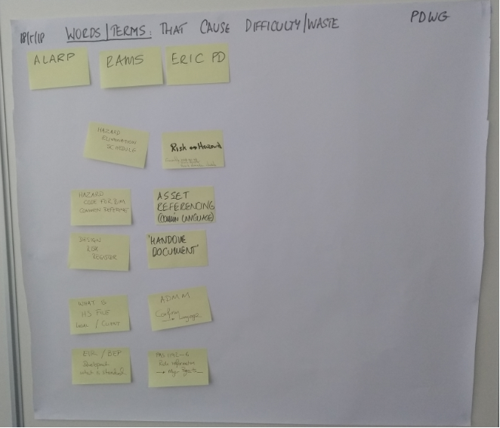
2. Good Practice - Share & Steal

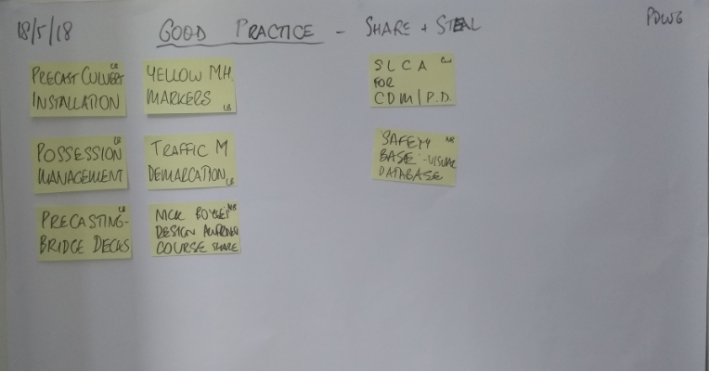

3. Precision - Areas Where there is Imprecision / Too many words
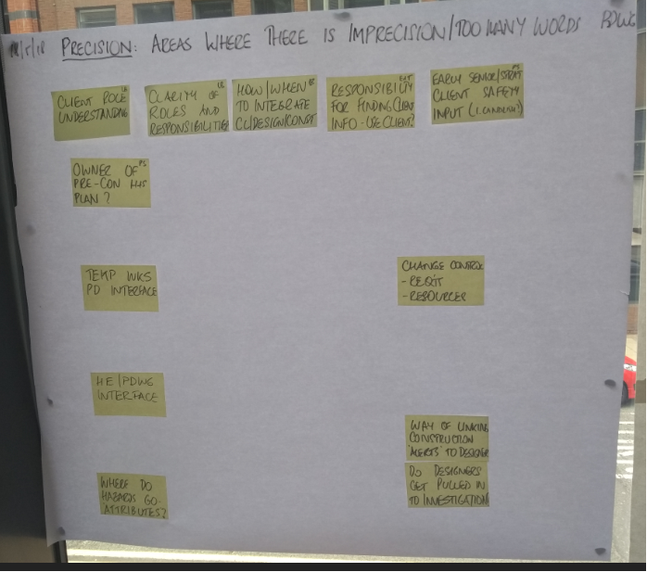
Actions from Meeting:
